Smoothing (Lowpass) Spatial Filters
Code:
import cv2
import matplotlib.pyplot as plt
monkey_image = cv2.imread("monkey.jpg")
if monkey_image is None:
exit()
monkey_image_rgb = cv2.cvtColor(monkey_image, cv2.COLOR_BGR2RGB)
kernel = (13, 13)
average_filtered_image = cv2.blur(monkey_image_rgb, kernel)
plt.figure(figsize=(12, 6))
plt.subplot(1, 2, 1)
plt.imshow(monkey_image_rgb)
plt.axis("off")
plt.subplot(1, 2, 2)
plt.imshow(average_filtered_image)
plt.axis("off")
plt.tight_layout()
plt.show()
Explanation of the Code:
- Image Loading:
  - The image monkey.jpg is loaded using OpenCV's cv2.imread. If the image is not found, the script exits.
- Color Conversion:
  - The image is converted from BGR to RGB for proper visualization using matplotlib.
- Lowpass Filtering:
  - A smoothing filter is applied using cv2.blur with a kernel size of 5×55 \times 55×5, which averages pixel intensities in the neighborhood, reducing noise and smoothing the image.
- Visualization:
  - The original and filtered images are displayed side-by-side to show the smoothing effect of the lowpass filter.

Output:
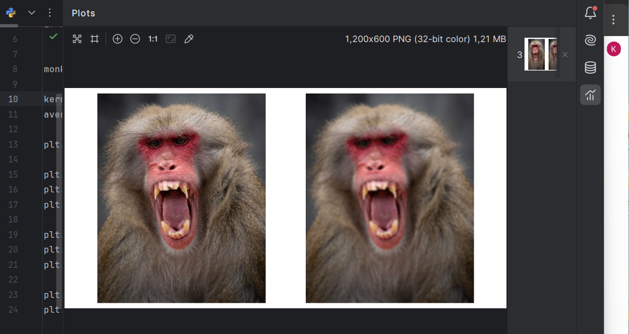

Report:
Filter Used: Averaging (Lowpass) Filter
- Purpose: Reduces high-frequency noise by averaging pixel values in a local neighborhood.
- Kernel Size: 5×55 \times 55×5, controlling the level of smoothing.
- Results:
  - Original Image: Retains all details, including noise or sharp intensity variations.
  - Filtered Image: Appears smoother, with noise and minor details reduced.
This approach is effective for basic smoothing but may blur edges. For applications where edge preservation is essential, other filters like bilateral or Gaussian may be preferred

